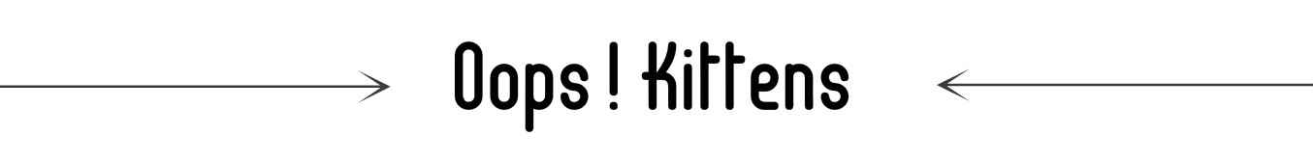

Before completing this application please read and mark the “I agree” box at the end
- You understand that the kittens have not received a health check or any vaccines on behalf of Oops! Kittens.
- That they have had a 14 day observation period during which no illnesses have presented.
- You agree that you will contact a vet of your choosing, pre pay and schedule the kittens sterilizing surgery prior to taking your kitten home
- In addition, in lieu of an adoption fee you agree to donate $25 to the SPCA Spay/Neuter bus on Oops! Kitten’s account (this fund pays for spaying Momma cats in the community your kitten came from)

☐ I agree

Section 1 Personal Information
Name
Address
Town And Postal;
Driver’s License;
Birthday;

Section 2 Which challenges are you willing to work on
Litter box Yes☐ No ☐ Not Applicable☐
Introduction to Children Yes☐ No ☐ Not Applicable☐
Introduction to Pets Yes☐ No ☐ Not Applicable☐
Destructive Scratching Yes☐ No ☐ Not Applicable☐
Food Sensitivities Yes☐ No ☐ Not Applicable☐
Grooming Yes☐ No ☐ Not Applicable☐

Section 3 Financial Expectations
Food $ Vet Care$ Supplies $ Grooming $ Boarding $

Section 4 Current Pets
Name Species Male or Female Spayed or Neutered
1 M☐F☐ Yes☐ No☐
2 M☐F☐ Yes☐ No☐
3 M☐F☐ Yes☐ No☐
4 M☐F☐ Yes☐ No☐

Section 5 History
- Have you had cats before Yes☐ No ☐
- Have you been charged with animal cruelty Yes☐ No ☐
- Do you have your Landlord’s permission if applicable Yes☐ No ☐
- Landlord’s Phone Number

